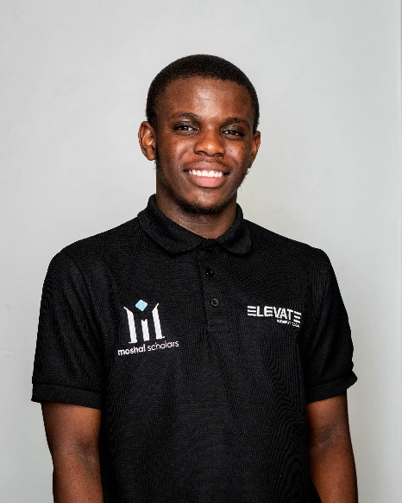

**PROFILE**

A motivated and dedicated Computer Science student at the University of the Witwatersrand, seeking to leverage academic knowledge and hands-on experience in software development, algorithms, machine learning, and data structures. Eager to apply problem-solving skills and continue learning in a professional work environment.

**WORK EXPERIENCE**

## Academic Tutor| University of the Witwatersrand

### Feb 2025– PRESENT

Assisting first year students with Introduction to Algorithms and Programming using python and C++. Basic Computer Organisation and Mathematical Modelling and Methods.

## Academic Tutor| Moshal Program

### Jul 2024 – Present

Assisting first year students with Programming using Python and C++ and also Data Structures using C++. Assisting second year students with Programming in Java and mobile development in android studio and java and building web services using PHP. Also assisting them with using MySQL.

**Volunteering**

**Head of Tutors| Wits Promaths**

### feb 2025 – Present

I am responsible for running the Promaths tutoring program,

making sure all runs smoothly. Managing tutors and the tutoring

programs within the organisation.

**Event Coordinator| Wits Promaths**

### oct 2023 – oct 2024

I was responsible for planning and making sure that all events

within the organisation run smoothly. From academic events, sport

events to entertainment events.

**Moshal Buddy| Moshal Program**

### feb 2024 – nov 2024

I was a mentor to two first year’s students in the Moshal program.

**Technical skills**

* Languages: JavaScript, Python, Java, C/C++, HTML & CSS
* Frameworks: Nodejs & ExpressJS, Flask, Tailwind, Jupyter Notebook
* Databases: MySQL, MongoDB
* Version Control: Git and Github

**Kgadi Selepe**

Johannesburg, Gauteng

+27 66 066 2316

kgadiselepe11@gmail.com

**EDUCATION**

## BSc Computer Sciences | University of the Witwatersrand

## Feb 2023 – Nov 2025

2024 – UG-UNIV Council Merit

2024 – Golden Key Society

2023 – Certificate of Merit, Scientific Computing I

2023 – Certificate of Merit,

Introduction to Algorithms and Programming I

2023 – University Entrance Scholarship

## National Senior Certificate |Katlehong Secondary

### **jan 2019 – dec 2022**

FULL HOUSE – 8 DISTINCTIONS

**SOCIALS**

**LinkedIn:** [**https://linkedin.com/in/kgadi-selepe-443271279**](https://linkedin.com/in/kgadi-selepe-443271279)

**GitHub:** [**https://github.com/pythonreus**](https://github.com/pythonreus)

**Website:** [**https://pythonreus.github.io/portfolio/**](https://pythonreus.github.io/portfolio/)